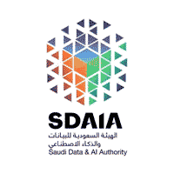

**T5 Boot camp**

**Data science**

Project proposal

NLP Dataset

Mohammad alajmi

Mohammad almalki

Yahya alyubi

Ghliah maher

Jamila Alharbi

Ghadeer Alghamdi

Instructor:

Mejdal Al-Qahtani

**Question/problem statement:**

In this project we are aiming to build a Chatbot system that takes a complains and problems about parking lot.

**The Data set:**

In this project we are about to search or generate our own dataset based on many methods such as google forms, tweets and many more methods.

**The used tools:**

different tools have been used to achieve this goal such as:

1. Python programming language
2. Numby library
3. Pandas’ library
4. Matplotlib library
5. SeaBorn
6. Sklearn
7. NlTK
8. Camel

**­­­­**

**The MVP:**

The main goal of this project is to build a chatbot System that receives complains and problems by interacting with people to help them in their problems in the parking lots.